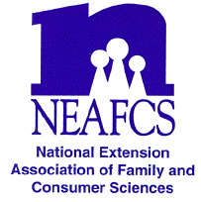
North Carolina Extension Association of Family & Consumer Sciences

The Professional Association of North Carolina Cooperative Extension Family and Consumer Educators

ADA B. DALLA-POZZA PROFESSIONAL DEVELOPMENT ENDOWMENT AWARD APPLICATION

NOTE: Application should be typed, double-spaced, up to three pages in length, with all pages numbered consecutively.

SUBMIT APPLICATION TO: Your district Vice President of Awards & Recognition by January 30, 2017. The winning application will be submitted to Laurie Edwards by the State VP of Awards and Recognition by appropriate deadline for Extension Awards.

PLEASE PRINT OR TYPE

Personal Information:

Name __________________________________________
Current Position ______________________________
Office Address _______________________________________________ County____________________________
City__________________________________________ State __________ Zip _______________________
Office Telephone______________________________ Home Telephone_______________________________
Years of NCEAFCS membership ____________________Years of NEAFCS membership ________________

Date: __________________________ Signature _________________________________________________
Applicant

I have reviewed this application and supplemental information and certify to it and the application or plan.

Date: __________________________ Signature _________________________________________________
Immediate Supervisor

On separate page(s) include the following:
- Overview of Extension Accomplishments (within the past three years)
- Involvement in NCEAFCS and other professional associations
- Future Plans for Professional Development
- Professional development experience planned for use of this award

Due JANUARY 30, 2017 to District Vice President of Awards and Recognition

