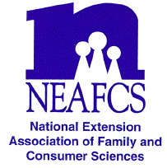

North Carolina Extension Association of Family & Consumer Sciences

The Professional Association of North Carolina

Cooperative Extension Family and Consumer Educators

EARLY CAREER AWARD APPLICATION

The following application must be completed and submitted along with documentation showing innovative and effective methods of conducting Extension Programs. Entries must be submitted by individuals. Teams are not recognized.
Name: ____________________________________________________________________________
Position: __________________________________________________________________________
County: ___________________________________ District: _______________________________
Complete Office Address: __________________________________________________________________________________
Office Telephone: __________________________ Home Telephone: __________________________
Years/Months employed with the NC Cooperative Extension: ________________________________
Years of membership with the NCEAFCS: _______________________________________________
On an attached sheet, not to exceed 2 typewritten pages, describe your accomplishments that document your innovative and effective methods of conducting Extension Programs.
On an attached sheet, not to exceed 2 pages, provide any supportive materials.
Attach a summary of your successes (not more than 50 words) that can be used in the State Awards Program book.
I certify that I am an active member with less than 10 years’ experience in NCEAFCS.

____________________________ ________________________________________________
Date Signature of Applicant

I certify that I have reviewed this application and verify that it has earned my approval.

____________________________ ________________________________________________
Date Signature of Immediate Supervisor

Due JANUARY 30, 2017 to District Vice President of Awards and Recognition

