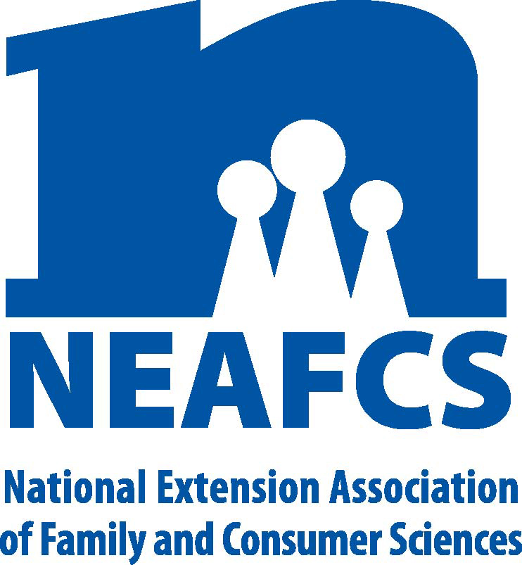

**North Carolina Extension Association of**

**Family & Consumer Sciences**

**The Professional Association for North Carolina Cooperative Extension**

**Family & Consumer Sciences Educators**

**2017 Professional Development Committee Plan of Work**

**Objectives:**

1. Increase knowledge among all NCEAFCS members of the opportunities for professional development through formal study, through workshops and seminars, and through distance learning opportunities.

2. Encourage exchange of research findings between districts and from state and national levels.

3. Encourage attendance at the NEAFCS meeting.

**Plan of Action:**

**1. Responsibilities of the District Professional Development Committee (Vice Presidents for**

**Professional Development)**

a. Investigate mailing lists that Extension agents should be aware of that would help them learn about upcoming seminars, workshops, mail groups and other professional development opportunities. Send information to members via the FCS mail group or send them to the State VP for Professional Development for distribution.

b. Encourage members to attain the most recent professional development activities at the various universities within the UNC system by accessing the website

<http://www.northcarolina.edu/content.php/campus/campusmap.htm>. This is a comprehensive guide, since it can link members directly to any university within the system. Once on a particular university site, conduct a site search for upcoming professional development activities.

c. Encourage members to become familiar with the NCEAFCS Professional Development Opportunities Handbook posted on the association’s website under “Professional Development”. Work with the State Vice-President of Professional Development to update the NCEAFCS Professional Development Opportunities Handbook.

d. Ask district members to send you any information they receive about opportunities for seminars, workshops, and other professional development opportunities; compile and forward the information to the State Vice President for Professional Development. The State VP will send this out via the FCS mail group. (The requested format for submission: title of workshop or class, sponsor, place, cost, brief summary of program content, contact person and telephone number.)

e. Encourage members to share research they have done or have read about with other members at your district meetings. Ask them to prepare an abstract of their research to share with other agents at the 2016 state meeting. Send these research abstracts to the State Vice President for Professional Development by June 1, 2017.

f. Encourage attendance at the national meeting of NEAFCS. Investigate the possibility of your district giving a partial scholarship to a first-time attendee who does not receive county support.

g. Send names of those completing advanced degrees and completing certification programs to the State Vice President for Professional Development by June 12, 2017.

h. Encourage members to post to the FCS mail group any books or articles they read that would be useful to other agents.

i. It is the responsibility of the State VP of Professional Development to request PDU’s from the National office for the NCEAFCS State Meeting for those with Certified Family and Consumer Sciences (CFCS) status.

j. Submit a yearly report of district accomplishments to the State Vice President for

Professional Development by June 12, 2017.

**2. Responsibilities of the State Vice President for Professional Development**

a. Solicit input from Extension specialists about upcoming Extension and non-Extension workshops and seminars that would be of interest to members.

b. Compile mailing lists sent by district chairs and post to the FCS mail group.

c. Update the NCEAFCS Professional Development Opportunities Handbook (created in 1999 and updated in July 2003) that is posted on the state association website at http://www.ces.ncsu.edu/assn/nceafcs/pdhandbook.htm

d. Investigate opportunities that already exist for scholarships to attend the national meeting of NEAFCS.

e. Recognize current members who have received advanced degrees and certification programs during the year with a small recognition gift. Recognition is to be given during annual business session.

f. Follow-up with host district Vice President for Professional Development to make sure that PDU’s are applied for those who with Certified Family and Consumer Sciences (CFCS) status.

g. Compete written guidelines on how to apply for PDU’s for those with are Certified Family and Consumer Sciences (CFCS) status and post on the web.

h. Compile district accomplishments and post the State Annual Report by August 1, 2017.

i. Prior to the NCEAFCS State Meeting in 2017, send a reminder to the FCS mail group about the Leadership Development Session that is held during the state meeting. Explain what the session is about and who is expected to attend.

**Committee Members:**

Toi N. Degree (SC) Chair, Cathy Hohenstein (W), Jennifer Grable (NC), Candy Underwood (SC)

Kelly C. Beasley (SE), Dee Furlough (NE)

**Submitted By,**

**Toi N. Degree**

**2017 State VP for Professional Development**

January 11, 2017