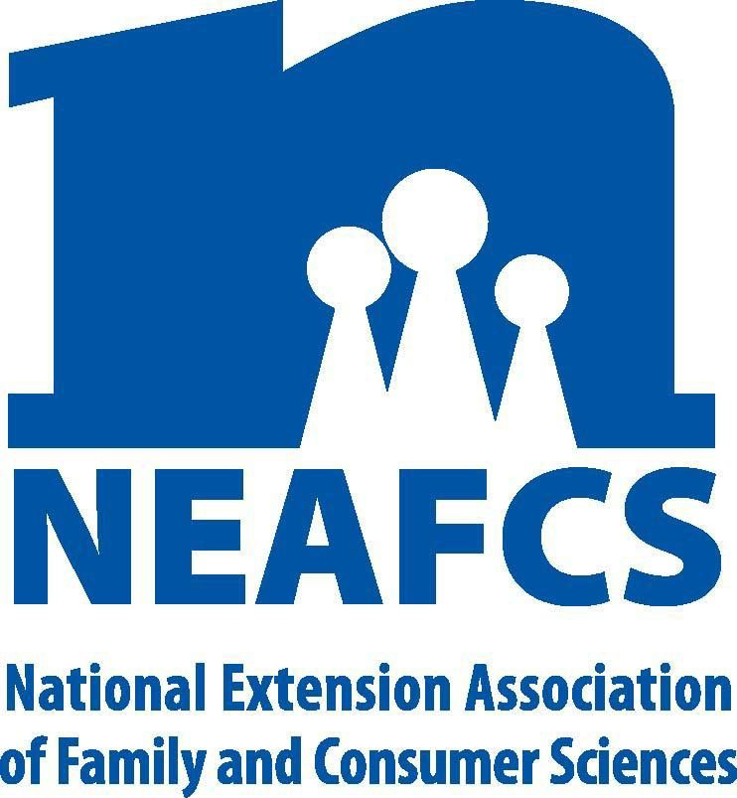 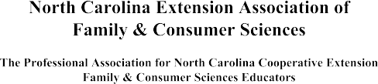

## 2019 Awards & Recognition Plan of Work

#### THE AWARDS AND RECOGNITION COMMITTEE SHALL:

1. Inform and promote among the Association's membership the Awards and Recognition program.
2. Encourage qualified members to submit applications for awards.
3. Develop and implement a plan of action which addresses issues related to awards.
4. Coordinate the awards application procedure and judging.
5. Recognize NCEAFCS members for outstanding leadership, innovative programming, dedicated service and superior performance.
6. Organize a filing system/notebook, which contains issues pertinent to the Awards & Recognition Committee and Budget.

# PLAN OF ACTION:

### District Vice President of Awards & Recognition Responsibilities:

* 1. Throughout the year "inform and promote" the Awards and Recognition program among the District membership.
  2. Familiarize yourself with the NEAFCS Awards Manual. Go to [www.neafcs.org](http://www.neafcs.org/) Click on “Awards” next click on “Awards Documents” and click on “Awards Manual/Guidelines”. Go to<https://nceafcs.ces.ncsu.edu/nceafcs-awards-and-recognition/nceafcs-state-awards/> for state award information.
  3. Encourage eligible district membership to apply for awards. Review NEAFCS General

Eligibility Requirements and Awards Applications Information & North Carolina's Procedures for Submitting Awards. Encourage Agents who have received awards to work with those who have not received awards and assist them in applying for an award. Ask former award winners to help members fill out award applications.

* 1. Receive from the district membership individual state awards applications by January 30, 2019 via email or US Mail.
     1. Awards must be received by District President of Awards and Recognition via email or postmarked by January 30, 2019.
        1. Members submitting national awards must also email their District VP of Awards and Recognition with the following information: Name(s), Award Name, County, Extension District & date award submitted online.
     2. National Awards are to be entered online through the [NEAFCS website](https://www.neafcs.org/awards).
  2. Review state award applications for completeness. Submit your [***District Awards information online via the District Award Summary form***](http://go.ncsu.edu/districtawardsummary) to the State VP of Awards and Recognition (Kristin Davis) by February 6, 2019.
  3. By February 13, 2019 District VPs will receive state awards applications, link for national award, judging sheets and instructions for judging from State Vice President of Awards for either Group A or Group B Awards. State VP will assign District VPs to either A or B judging team based on 2019 award applications to avoid any conflict of interest in judging. Judging sheets should be completed and submitted per instructions provided by the State VP Chair by February 22, 2019.
  4. Recognize State Award Winners at the District Association Meetings and gatherings AFTER state meeting.
  5. Keep a permanent record in your awards notebook of Agents in the district that receive Awards & Recognition honors. Update these records each year before passing them on to the incoming District Vice President of Awards & Recognitions.
  6. Submit reimbursement requests (along with receipts) to the District President for approval for reimbursement of expenses for mailing district applications.

**State Chairs for Group A & B Awards Responsibilities:**

1. Familiarize yourself with the NEAFCS Awards Manual. Go to [www.neafcs.org](http://www.neafcs.org/) Click on “Awards” next click on “Awards Documents” and click on “Awards Manual/Guidelines”. Go to<https://nceafcs.ces.ncsu.edu/nceafcs-awards-and-recognition/nceafcs-state-awards/> for state award information.
2. Promote the Awards and Recognition Program.
3. By February 22, 2019 Group A and B State Chairs will receive the judging results from

District Vice Presidents serving on either Group A or B committee. In the event of tie, the Group A or B Chair will review applications and select a winner. Complete the [***2019***](https://docs.google.com/spreadsheets/d/1iUhGImk93m38WqEuxnPekd0UfRD2k07MCCKsZQCYmrk/edit?usp=sharing)[***District Award Winner Sheet***](https://docs.google.com/spreadsheets/d/1iUhGImk93m38WqEuxnPekd0UfRD2k07MCCKsZQCYmrk/edit?usp=sharing) indicating all first and second place winners (Exceptions: DSA and Continued Excellence winners – number of entries are determined by the number of paid members of NCEAFCS by the January 1, 2019 deadline). By March 1, 2019 upload all judging sheets into the shared [Google Drive folder](https://drive.google.com/drive/folders/1vys7YoQE3_DbuT-Wogh7UgvCDwhlMy4u?usp=sharing) and the ***be sure to complete the*** [***2019 District Award Winner Sheet***](https://docs.google.com/spreadsheets/d/1iUhGImk93m38WqEuxnPekd0UfRD2k07MCCKsZQCYmrk/edit?usp=sharing)for access from the State VP of Awards & Recognition (Kristin Davis).

1. Assist the State Vice President of Awards and Recognition in recognizing award winners at state meeting.
2. Submit reimbursement requests (along with receipts) to the State Vice-President of Awards and Recognition to be forwarded to the State President for approval.

### State Awards and Recognition Vice President Responsibilities:

1. Chair the Awards & Recognition Committee and serve as liaison between the committee and the State Executive Board.
2. Present a proposed budget before leaving the Annual State Meeting.
3. By September 30th, submit Plan of Work to the current State Vice President for Public Affairs. Send copy to State President. State Vice President for Public Affairs sends to webmaster for posting.
4. Provide District Vice Presidents with the needed information for their Fall district meeting reports.
5. By December 31st, submit NEAFCS National Committee/Task Force Application, in order to have a link to the National Committee for awards information.
6. Notify the NC Agricultural Foundation via e-mail of the contact information for the current NCEAFCS State Vice President Awards and Recognition, as the contact person for the Ada Dalla Pozza Professional Development Endowment.
7. Request membership list from State NCEAFCS Treasurer.
8. By February 13, 2019 email state award applications, link for national awards and judging sheets to District VPs of Awards and Recognition.
9. By March 1, 2019, receive all judging sheets and [***2019 District Award Winner Sheet***](https://docs.google.com/spreadsheets/d/1iUhGImk93m38WqEuxnPekd0UfRD2k07MCCKsZQCYmrk/edit?usp=sharing)

sheet from Group A and B Chairs. Verify score sheets and compile list of state winners.

1. Request letters of support from the Family and Consumer Sciences State Program Leader, to be sent with applications to National judging for the following awards - Greenwood Fellowship, Grace Frysinger Fellowship, Distinguished Service, Continued Excellence, NAEFCS Extension Educator of the Year, Florence Hall, New Professional, Mary W. Wells Memorial Diversity Award, and Community Partnership.
2. By March 3, 2019 notify all first and second place winners (Exceptions: DSA and Continued Excellence winners – number of entries are determined by the number of paid members of NEAFCS by the January 1 deadline). For the Youth Award and the Early Career Award, which are state awards only, one winner shall be selected from each of the Association’s districts. In the event there is more than one application from a district but a total that doesn’t exceed the number of districts (currently five – 2019) more than one winner may be named from a district. National awards may be edited for any improvements suggested on judging sheets up until the March 15, 2019 deadline.
3. Submit 2019 State Winner Form online (www.neafcs.org) by March 15, 2019 deadline.
4. Send congratulatory letters to award winners. Letter should include state meeting award banquet information. Send copy of letter to County Director and District Director.
5. Send list of winners to NCEAFCS State President and to Family and Consumer State Program Leader. No announcement of winners is to be made to membership or public until after State Meeting.
6. Order appropriate plaques, crystals or acrylics selected by the State VP and approved by the Awards and Recognition Committee (Approved Executive Board Meeting, January 11, 2016). All Cooperative Extension team members who are members of NEAFCS will receive the appropriate plaque, crystal or acrylic. Certificates will be given to second place winners. Certificates will be given to all others first place winners (Extension employees that are not members of NEAFCS or non-extension employees (Approved Annual Meeting, 1999). If NEAFCS members wish to purchase plaques, crystal or acrylics for non-members this may be done with advance notice to the State VP of Awards and Recognition. These may be purchased at the cost of the plaque, crystal or acrylic and paid for in advance directly to the State Treasurer.
7. Submit award information to the host district of all state award winners for the printed program for the Annual State Meeting.
8. Contact the host district prior to the Annual State Meeting to verify the agenda, photography opportunities, registration recommendations for invited guests, and the presentation of awards. Notify award winners of details of the awards presentation and ask for names of winners and their guests who plan to attend state meeting. Be sure to determine if there is an additional cost for more than one banquet guest accompanying awardee. Once compiled, send this list to the host district for seating arrangements.
9. Upon notification from NEAFCS, announce National winners to awards committee, State

President and FCS State Program Leader. Congratulate National winners and notify administration to encourage financial support for attending national meeting. National rules prohibit any public announcement of National or Regional winners until after the National meeting.

1. Organize the presentation of awards and recognize the winners (and guests) at the State Meeting. Host district is responsible for decorating, inviting speakers/guests, and layout of ceremony. State VP is only responsible for coordinating presentation of awards.
2. Notify NC Agricultural Foundation of winner for the Ada Dalla Pozza Award and request check. Notify Extension Administration (State Extension Awards Committee) of winner for inclusion in the awards presentation of Extension's Annual Conference.
3. Contact State President to order corsages for national winners to wear at the National Meeting Awards Banquet.
4. Keep accurate and detailed records of Awards & Recognition activities and expenses.
5. Submit reimbursement requests (along with receipts) to the State President for approval. Forms for requesting reimbursement can be accessed via the association web page.
6. Keep a permanent record of agents who have received Association awards and honors.
7. Submit an annual report via e-mail to the State VP for Public Affairs and present annual report at the State Business Meeting.
8. Organize Awards & Recognition Files and transfer the records to the incoming State Vice President of Awards & Recognition during annual training session at State Meeting.
9. Send State and National winners to awards page web master for posting. This can be done as soon as winners are selected, but not available to view until AFTER state meeting.

# 2019 Awards & Recognition Timeline

|  |  |  |
| --- | --- | --- |
| **Deadline** | **Objective** | **Task** |
| **January 30, 2019** | All national awards submitted online. | Email should be sent to District VP of Awards and Recognition with the following information:   * Name(s) * Award Name County * District * Date award submitted online.   **State awards should be either scanned and emailed to District VPs or postmarked and mailed to District VPs. *Email is the preferred method.*** |
| **February 6, 2019** | Provide District Awards Summary sheet to State VP. | District VPs will upload district award applications into District Award Summary form online at [go.ncsu.edu/districtawardsummary](http://go.ncsu.edu/districtawardsummary) |
| **February 13, 2019** | Initiate District Awards judging process. | District VPs will receive state award applications, link for national awards and judging sheets, including Group A & B assignments. |
| **February 22, 2019** | Return judging sheets to Group A & B Chairs. | District VPs will send judging sheets to either Group A or B Chair. In the event of a tie, the Group A or B Chair will review applications and select a winner. |
| **March 1, 2019** | Provide State VP with Winner Summary Sheets. | Group A & B Chairs will upload judging sheets into shared Google folder and add names of winners 2019 [District Award Winner Sheet](https://docs.google.com/spreadsheets/d/1iUhGImk93m38WqEuxnPekd0UfRD2k07MCCKsZQCYmrk/edit?usp=sharing) (accessible only to group A & B chairs). |
| **March 3, 2019** | Announcement of winners. | State VP will notify winners.  *National awards may be edited for any improvements suggested on judging sheets up until the March 15, 2019 deadline.* |
| **March 15, 2019** | Submit winner forms to National platform. | State VP will submit ***State Winner Form*** online.  *Last day to complete national award applications, upload documents and/or make edits.* |

**NC PROCEDURES FOR SUBMITTING AWARDS:**

1. Review NEAFCS General Eligibility Requirements and Awards Applications Information at [www.neafcs.org](http://www.neafcs.org/) (Awards Tab, Awards & Guidelines Manual).
2. Refer to the NEAFCS Awards Manual for all National Awards. Go to [www.neafcs.org](http://www.neafcs.org/) Click on the “Awards” next click on “Awards Documents” and click on “Awards Manual/Guidelines”. Go to

<https://nceafcs.ces.ncsu.edu/nceafcs-awards-and-recognition/nceafcs-state-awards/> for State Award information.

1. Submit state award applications by January 30, 2019 via email or US Mail to your District VP of Awards & Recognition.
   1. State awards must be received via email or postmarked by January 30, 2019.
   2. National Awards are to be entered online through the NEAFCS website by January 30, 2019.
   3. Members submitting national awards must also email their District VP of Awards and Recognition with the following information: Name(s), Award Name, County, Extension District & Date award submitted online. Read and follow on-line application process carefully for national awards. Pay special attention to word limits, spacing, and appropriate signatures.

##### NOTE: Applications received after the deadline will not be judged.

**2019 NCEAFCS Awards and Recognition Committee:**

State Vice President for Awards and Recognition, Chair - Kristin Davis

**District Vice Presidents for Awards and Recognition** North Central - Carmen Long, Surry County Northeast - Jewel Winslow, Perquimans County

South Central - Der Holcomb, Iredell/Catawba County Southeast - Shenile Ford, Greene County

West - Margie Mansure, Watauga County

**Awards Group A**

#### State Chair for Awards Group A – Shenile Ford (Southeast District)

|  |  |
| --- | --- |
| **National Awards** | |
| Early Childhood Child Care Training Award | Food Safety Award |
| NEAFCS Greenwood Frysinger Award | Marketing Package Award |
| NEAFCS Distinguished Service Award | Community Partnership Award |
| NEAFCS Continued Excellence Award | Clean and Healthy Family & Communities Award |
| NEAFCS Educator of the Year | Family Health & Wellness Award |
| Florence Hall Award | Environmental Education |
| NEAFCS Past President’s New Professional Award | School Wellness |
| Human Development/Family Relationship | Master FCS Volunteer Award |
| Social Networking/Blog Category |  |

|  |  |
| --- | --- |
| **State Awards** | |
| Early Career Award | Grange Award |

**Judging Committee Members:**

**To be determined by State VP once award applications are received to avoid any conflict of interest.**

## Awards Group B

#### State Chair for Awards Group B – Margie Mansure (West District)

|  |  |
| --- | --- |
| **National Awards** | |
| Dean Don Felker Financial Management Award | Communications Television/Video Program Awards |
| Mary W. Wells Diversity Awards | Communications Educational Curriculum Award |
| Program Excellence Through Research Award | Communications Educational Publications Awards |
| Communications Newsletters Awards | Communications Photography Award |
| Communications Written Press Awards | Communications Internet education Technology Award |
| Communications Radio/Podcast Program Award | Extension Housing Outreach Award |
| Communications Educational Technology Award | Innovative Youth Program Development Award |

|  |  |
| --- | --- |
| **State Awards** | |
| Youth Awards | Federation: Leadership & Service  Recognition Award |

Note: The Ada Dalla Pozza award will not be included in the NCEAFCS call for awards. Beginning 2019, it will be included in the Extension call for awards and judged by the NCEAFC Awards and Recognition committee.

**Judging Committee Members:**

**To be determined by State VP once award applications are received to avoid any conflict of interest.**

##### Updated 11/2018