72nd Annual Wayne County
Junior Livestock Show and Sale
April 15 & 16, 2020

REGISTRATION FORM

Deadline: January 31, 2020

Birth date: / / |  | Exhibitor’s age as  of Jan. 1st 2020 |  |  |  |  | Grade in  School
Exhibitor Name:

Mailing Address:

City: |  |  | State: |  | Zip:
Phone Number(s):
E-mail address:
Parent or Guardian’s Name:
T-Shirt Size: Youth or Adult (please circle) YS YM YL AS AM AL AXL
If you need a bigger size, please write in:
Number of Animals: Maximum of two per species may be entered and shown. (Please see General Rule # 12.) Please enter the number below.

Animals must be in Exhibitor’s possession by January 31,
(75 days prior to the Jr. Livestock Show and Sale) NO EXCEPTIONS.

Number of  Goats: | Number of  Steers: |  |  | Number of  Heifers: |  | Number of  Market Hogs:

I have read, understand, and will follow all rules (including the National Code of Show Ring Ethics) associated with the 2016 Wayne County Junior Livestock Show and Sale.
I also agree to allow blood or other tests to my animal upon request. (Please sign)

Exhibitor: _____________________________________________

Parent/guardian: _______________________________________

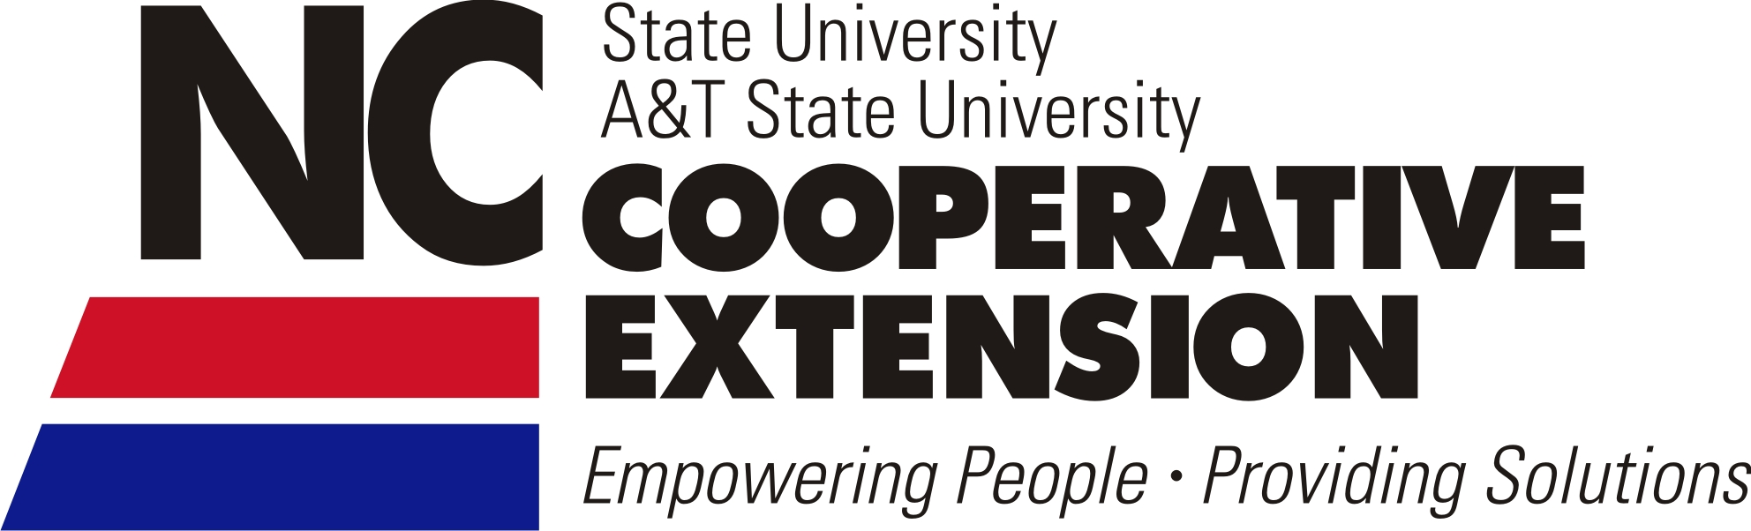
Return To:
NC Cooperative Extension
Stefani Sykes, Extension Agent
P. O. Box 68, Goldsboro, NC 27533-0068
Phone: (919) 731-1525 Fax: (919) 731-1511

