# **[How to Make an Inexpensive Footbath](http://wisconsinjuniorpoultryassociation.org/how-to-make-an-inexpensive-footbath/)**

**Footbaths: An Easy Way to Protect Your Flock**

With Avian Influenza cases in Wisconsin and other states, practicing biosecurity with your flock is even more important than usual. One biosecurity tool that will help keep your flock healthy is a disinfecting footbath. Footbaths are not hard to make, and they don’t have to be expensive. By following the steps below, you can easily create your own footbath.

**Step 1**. **Assemble** the following supplies: Shallow plastic or metal tub with lid, small rubber door mat, scissors/shears. Cost of these supplies depends on what you have on hand, but can range from $0-$20.

*This small tub and rubber mat are suitable for use in a footbath.*

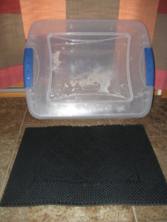

**Step 2. Cut** the rubber mat so that it fits inside the tub. Then, place the mat into the tub. Be sure to place the mat rough-side up, since you want to be able to remove debris from your boots by scraping them against it.

**Step 3. Make a disinfecting solution.** You only need enough of the solution to thinly cover the bottom of your shallow tub. One-half inch should be sufficient.

Good disinfectant choices include bleach, Oxine (not activated), and Tek-Trol. Bleach may damage some materials, but it is effective. Oxine is probably the weakest of the disinfectants listed, though it still helps kills pathogens. Tek-Trol, the strongest disinfectant, can be somewhat expensive, but it’s power makes it worth the cost.

Disinfectant mixing instructions:   
**Oxine:** Mix 1-1/2 tablespoons into 2 cups of water (this amount of water should be sufficient to cover the bottom of the footbath tub).  
**Tek-Trol:** Mix approximately 1/2 teaspoon in 2 cups of water.  
**Bleach:** Mix 4 teaspoons of bleach (1-1/3 tablespoons) in 2 cups of water.

*Note: The disinfectant used in your footbath is likely to be the most costly item ($10-$50). Fortunately, most disinfectants are sold in rather large containers, so they’ll last a while and make up for their initial cost.*

*These are three disinfectants that work well in a footbath: Oxine, Tek-Trol, and Bleach.*

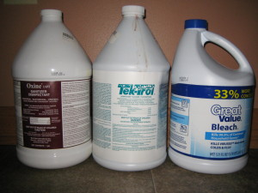

**Step 4. Pour** the disinfecting solution into the tub (or, alternatively, mix it up in the tub). Then, you’re done making your footbath!

*This is what your completed footbath should look like, before the disinfectant is added.*

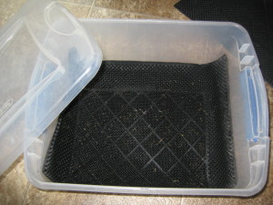

**How to use:** To use the footbath, place it close to your poultry coop’s door. Before you enter the coop, step briefly in the footbath, and rub your shoes around in it vigorously. You should also use the footbath again after leaving the coop, so that you don’t track bacteria from your own coop into other flocks/areas. For greater biosecurity measures, station a stiff brush next to the footbath. Before stepping into the footbath, brush debris off your boots.

***Please note:***Some of the disinfectants may damage fancy shoes or clothes that drag in the water. Rubber boots are suggested.

Change the footbath’s disinfecting solution whenever it becomes dirty, or after about a week.

Be sure to keep the lid on the footbath when it’s not in use. You don’t want any animals drinking from it and you’ll want to minimize the debris that falls into it (leaves, grass, etc.)

From: http://wisconsinjuniorpoultryassociation.org/how-to-make-an-inexpensive-footbath/