

**Grant Opportunity**

**For Family Farms**

NC AgVentures is an Extension program

provides grants to NC independent farmers for

agricultural project ideas that will increase farm profits.

**The program will award a minimum of 50 grants**

**The maximum award is $8000**

**Producers from the following counties are eligible to apply**

Alamance, Alexander, Alleghany, Anson, Ashe, Cabarrus, Caswell, Catawba,

Chatham, Davidson, Davie, Durham, Edgecombe, Franklin, Forsyth, Gaston, Granville,

Greene, Guilford, Halifax, Harnett, Iredell, Johnston, Lincoln, Martin, Mecklenburg, Nash,

Northampton, Orange, Person, Pitt, Randolph, Rockingham, Rowan, Sampson, Stanly,

Stokes, Surry, Union, Vance, Wake, Wayne, Wilson, Wilkes, Warren, Yadkin   

**Deadline to apply is 6:00 PM December 13th, 2024**

For more information please visit: [www.ncagventures.org](http://www.ncagventures.org)

Or contact your Extension Agent

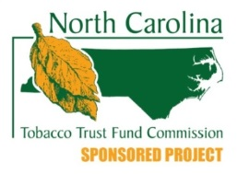The program is funded by the NC Tobacco Trust Fund Commission