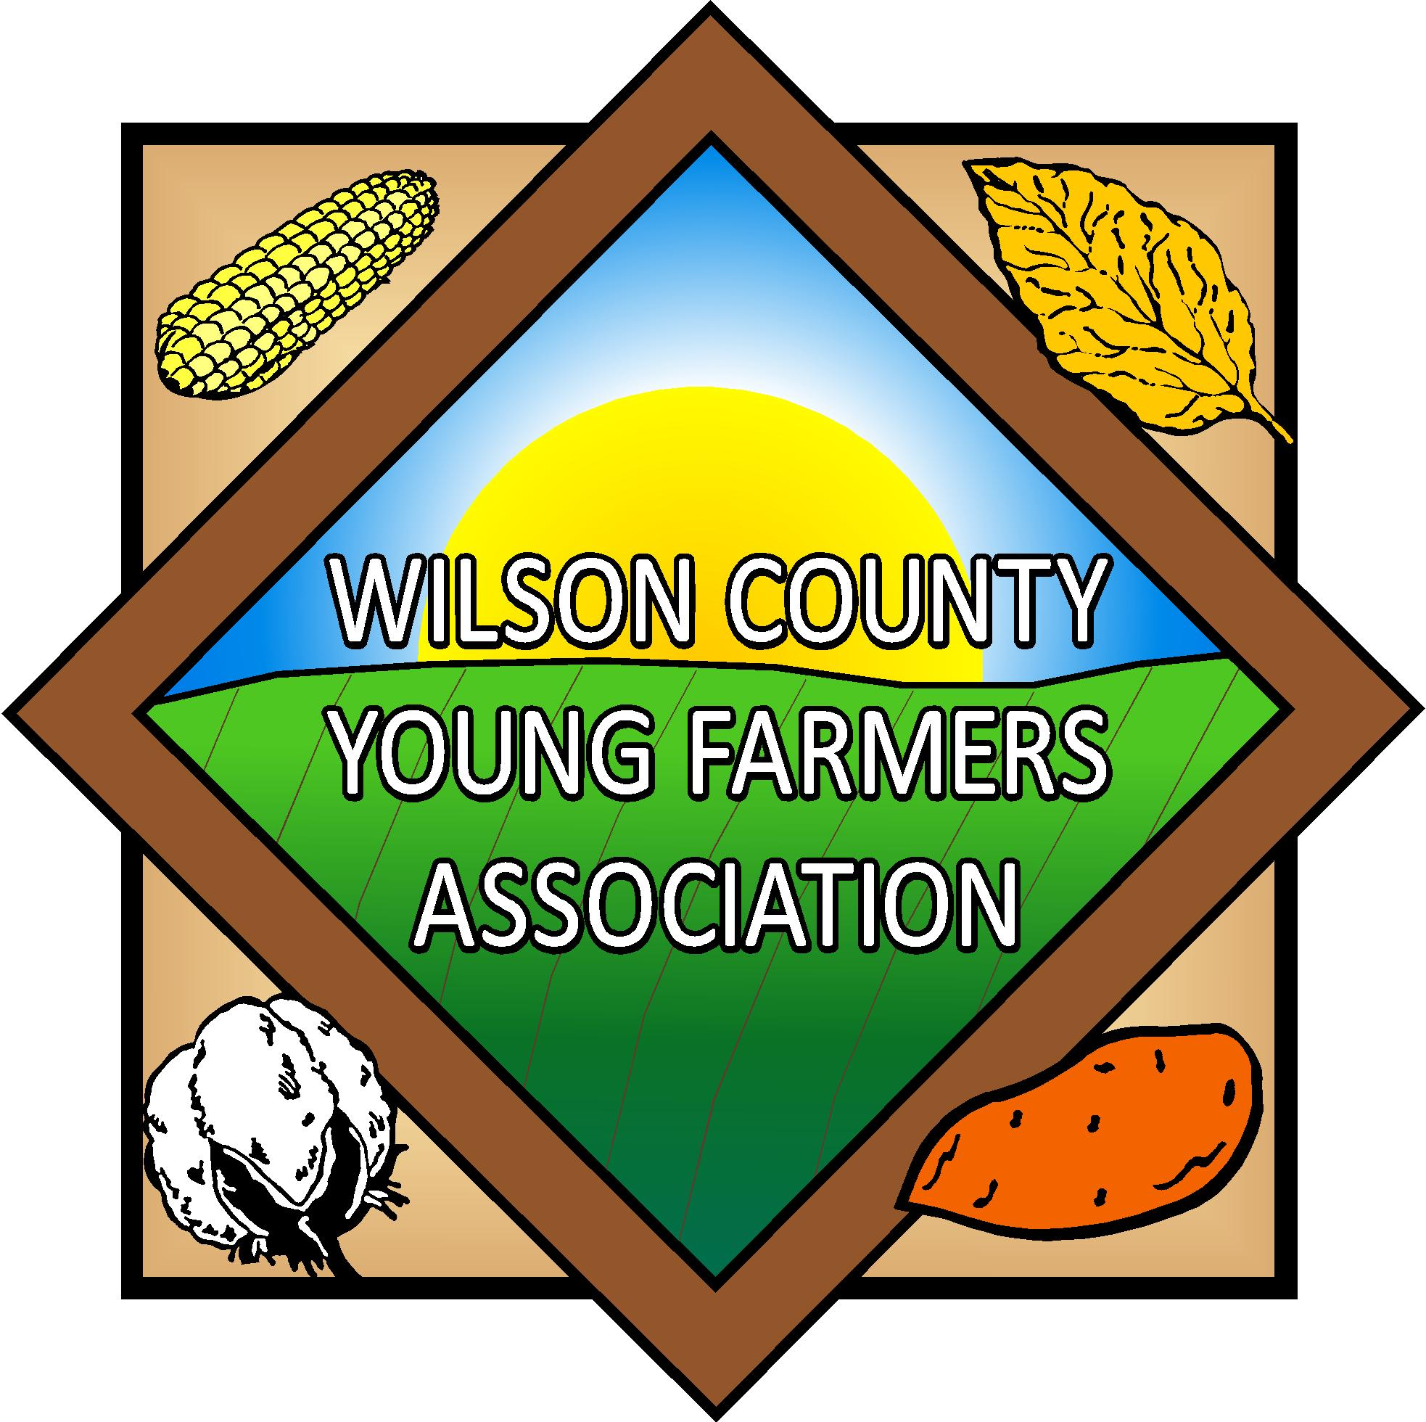
Mark Batts Memorial
4-H and FFA Scholarship

The Wilson County Young Farmers Association will be offering a $500 scholarship to a Wilson County 4-H or FFA member senior who is planning education beyond high school. Mark Batts was a life long farmer who was actively involved with the WCYFA. The WCYFA created this scholarship in his memory.

Objective

To recognize and provide financial assistance to Wilson County Senior 4-H or FFA member who plan to continue their education beyond high school.

Regulations or Stipulations

1. Awarded to a Wilson County Senior 4-H or FFA member.

2. Forms must be submitted prior to 5:00 PM on April 5, 2024.

3. It is not necessary to attend a four-year college or university to be eligible but enrollment in a formal continuing education program is required.

4. This award will be given jointly to the individual and their chosen institution of higher learning. This is not a cash award.

If you have any questions, contact Norman Harrell, County Extension Director, NC Cooperative Extension Service, Wilson County at (252) 237-0111 or neharrel@ncsu.edu.

NC Cooperative Extension – Wilson County
Attention: Wilson County Young Farmers Association
Mark Batts Memorial Scholarship
1806 SW Goldsboro St., Wilson, NC 27893

Wilson County Young Farmers Association
Scholarship Application

Name:

Address:

Age:

What 4-H or FFA Club are you a member of?

High School attended:

Grade:

Date of Graduation

Have you been accepted to a college, university or technical school? ______ Yes ______ No

If no, have you made applications for admission? ______ Yes ______ No

If yes, name of college, university or technical school.

Type of degree:

Major or intended area of study:

Please answer the following questions

Please list or describe leadership roles and activities you have been involved with.

Please describe or list community service you have been involved with and any Citizenship Awards you may have received.

What 4-H or FFA activities have you been involved with?

Please give a brief narrative on your field of study, career choice and plans for the future.

How has 4-H or FFA impacted your life? (brief narrative)

