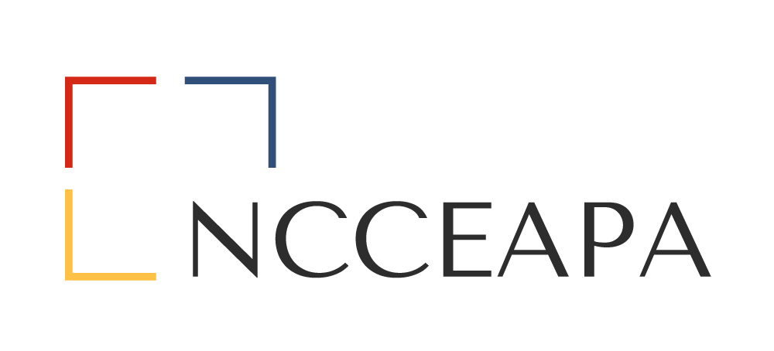
20__ – 20__ Officers
Name – President
Name – 1st Vice President
Name – 2nd Vice President
Name – Secretary
Name – Treasurer
Name – Parliamentarian
Name – Advisor
Name – Federation Officer

NCCEAPA Executive Board Meeting
Month Day, 20__ @ Time
Location

President’s Name, Presiding
Name, Parliamentarian

AGENDA
Agenda Item | Discussion |  |  |  |  | Outcomes and Next Steps
Call to Order  Name, President | Call to Order Time:
Roll Call  Name, Secretary | President’s name | 1st VP’s name | 2nd VP’s name | Secretary’s name | Treasurer’s name |  | Parliamentarian’s name | Advisor’s name | NCJCEP officer’s name
Parliamentary Review  Name, Parliamentarian | Verify quorum
Approval of Agenda  Name, President |  |  |  |  | Motion to accept:  Seconded:  Decision:
Thought for the Day
Name, 1st Vice President
Approval of Minutes  Name, Secretary | Executive Board Minutes  date of last Executive Board Meeting |  |  |  | Motion to accept:  Seconded:  Decision:
Old Business
Other Old Business
New Business
Treasurer’s Financial Report & 20__-__ Proposed Budget  Name, Treasurer |  |  |  |  | Proposed Budget Recommendation from Committee  Seconded:  Decision:
20__ Mills Lighthouse Award  Name, President |  |  |  |  | Motion to accept:  Seconded:  Decision:
20__ Distinguished Service Award  Name, 1st Vice President |  |  |  |  | Motion to accept:  Seconded:  Decision:
20__ Executive Board Award  Name, 1st Vice President |  |  |  |  | Motion to accept:  Seconded:  Decision:
20__ Herter-O’Neal Scholarship  Name, 2nd Vice President |  |  |  |  | Motion to accept:  Seconded:  Decision:
Honorary Membership  Name, Membership Chair |  |  |  |  | Motion to accept:  Seconded:  Decision:
Federation Report
Name, Advisor
20__ State Meeting Update
Name, District
TERSSA Report
Name, NC TERSSA Representative
Other
Other Business
Upcoming Deadlines
April 1, Year | Herter-O-Neal Scholarship Application –, 2nd Vice President
August 1, Year | Executive Board Award Nominations –, 1st Vice President
August 1, Year | Distinguished Service Award –, 1st Vice President
August 1, Year | Honorary Membership Nominations –, State Membership Chair
August 1, Year | Professional Improvement Scholarship – ,Professional Improvement Chair
August 1, Year | Sue Mills Lighthouse Award Nominations – , State President
August (?) | Horn of Plenty, Location
Date | TERSSA National Meeting –
Date | NCCEAPA Executive Board Meeting,
Date | NCCEAPA Board of Directors Meeting,
Date | NCCEAPA Annual State Business Meeting,
Date | Federation Forum
Other Announcements
Adjourn |  |  |  |  | Motion to accept:  Seconded:  Decision:

