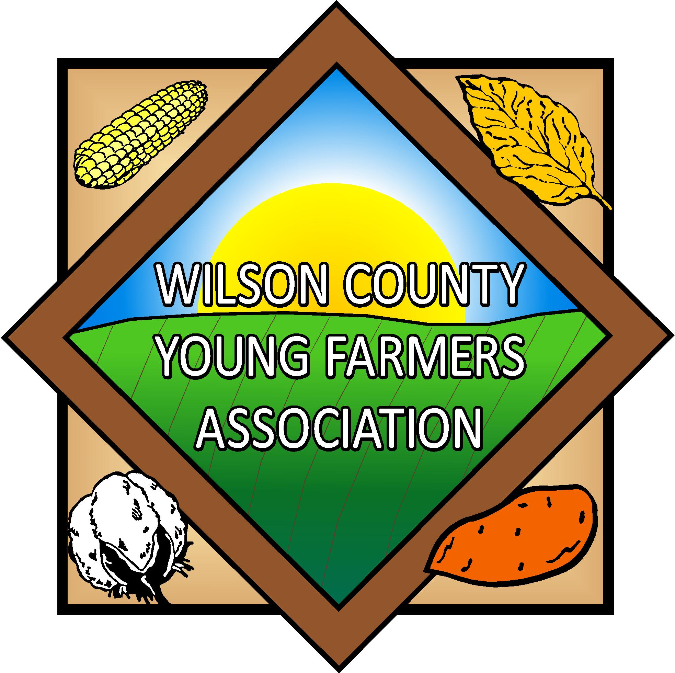
Wilson County Young Farmers Association 4-H Scholarship

The Wilson County Young Farmer's, Inc., in conjunction with the Wilson County 4-H Livestock Program, will be offering two $1500 scholarships to Wilson County Senior 4-H'ers who are planning education beyond high school. Attendance at a four-year school is not required, but recipients must be enrolled in a formal education program beyond high school.

Objective

To recognize and provide financial assistance to Wilson County Senior 4-H'ers who have been involved in the livestock program and plan to continue their education beyond high school.

Regulations or Stipulations

1. Awarded to Wilson County Senior 4-H'ers (14-18 as of Jan. 1).

2. Forms must be submitted prior to 5:00 PM on March 12, 2024 to be considered.

3. It is not necessary to attend a four-year college or university to be eligible but enrollment in a formal continuing education program is required.

4. 4-H'ers must have been enrolled in a 4-H livestock project to be eligible.

5. Once this scholarship has been awarded, it cannot be won by that same individual again.

6. This award will be given jointly to the individual and their chosen institution of higher learning. This is not a cash award.

If you have any questions, contact Norman Harrell, County Extension Director, NC Cooperative Extension Service, Wilson County at (252) 237-0111 or neharrel@ncsu.edu.

NC Cooperative Extension – Wilson County
Attention: Wilson County Young Farmers Association Scholarship
1806 SW Goldsboro St., Wilson, NC 27893

Wilson County Young Farmers Association
Scholarship Application

Name:

Address:

Age:

What 4-H Club are you a member of?

High School attended:

Grade:

Date of Graduation

Class rank:

GPA:

SAT score:

Have you been accepted to a college, university or technical school? ______ Yes ______ No

If no, have you made applications for admission? ______ Yes ______ No

If yes, name of college, university or technical school.

Type of degree:

Major:

Please answer the following questions

Please list or describe leadership roles and activities you have been involved with.

Please describe or list community service you have been involved with and any Citizenship Awards you may have received.

What 4-H activities have you been involved with?

Please give a brief narrative on your field of study, career choice and plans for the future.

How has 4-H impacted your life? (brief narrative)

