___________
GATES COUNTY
Dalure Farms | LuLu 357-0587 & Dawn Eure, 331-3327, 166 Harrell Lane, Eure | April-Oct/Nov, Mon-Sun, daytime hours | Asparagus, kale, corn, tomatoes, watermelon, onions, S.C. peaches, collards, pumpkins | Call for availability.

Gates County Farmer’s Market | Jody or Tommy, 357-1867, Adjacent to Brinkley’s Hardware in Gates (Highway 37N) |Memorial Day Weekend -September, Tues/Thurs/Sat. Call for hours| Fresh local produce, eggs, baked goods, jams, jellies, honey, local crafters.

Kenny Hobbs, 562-5378 (call first) | 558 Spivey Rd., Hobbsville | Anytime, September & October | Scuppernog Grapes Pre-picked or PYO
________________
PERQUIMANS COUNTY

Dean Lane | 297-2592 | 1147 Belvidere Rd., Belvidere | July- Aug, Mon-Sat, Sunup to sundown | Watermelon.

Haven Acres Farm | William & Tara Fowler, 209-1954, 287-8640, 1027 Beech Springs Rd, Hertford | 3rd weekend in June, Tues 5pm-9pm, Sat 9am-2pm. | Peaches, seasonal vegetables, homemade ice cream | Call for details.

Jesse Byrum's Produce |Jesse Byrum, 312-5938, Corner of Church & Grubb Streets, Hertford | Year round weather permitting, Mon-Sat, 10am-6pm | Fruit & vegetables, seasonal local produce.
Looking Back Farms/Perry’s Farm | Ken & Ben Haines, 426-2218, 589 Chinquapin Rd,Tyner | 1st Sat after Jul 4th for 5 weeks 7am-5pm for PYO organic Blueberries & 1st Tues after Labor Day for 5 weeks on Tues, Thurs, & Sat 8am-5pm for PYO organic Muscadine Grapes | May also buy seasonal organic vegetables.

Perquimans Market—“The Market at Missing Mill” |Pam Moore, (marketinfo@historichertfordinc.org),| Missing Mill Park, Grubb St, Hertford | Wednesdays May 1-Oct , 9am- 2pm |

Tommy Harrell Farms | Tommy & Sherry Harrell, 426-5145 | Call for hours | 279 N Bear Swamp Rd, Hertford | August-Frost | Lima beans.

Newbold White House Vineyard | Walker Rayburn, 426-7167 | 151 Newbold-White Rd., Hertford | Open Saturday mornings from late August through September. | PYO Muscadine Grapes

Listings are included in this brochure as a convenience to the reader. Any mention or listing of products or services does not imply endorsement by North Carolina Cooperative Extension nor discrimination against similar products or services not mentioned.

Hours & dates are subject to change. Call ahead to confirm.
All numbers are area code 252.
PYO= Pick Your Own
For questions/additions/deletions/corrections, please call 482-6585

2013 Produce Guide

Chowan, Gates, Perquimans
Pasquotank & Camden Counties

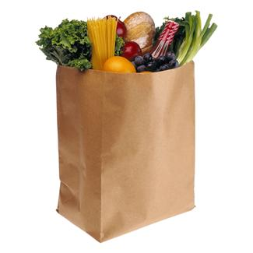

Buy Fresh
…Buy Local

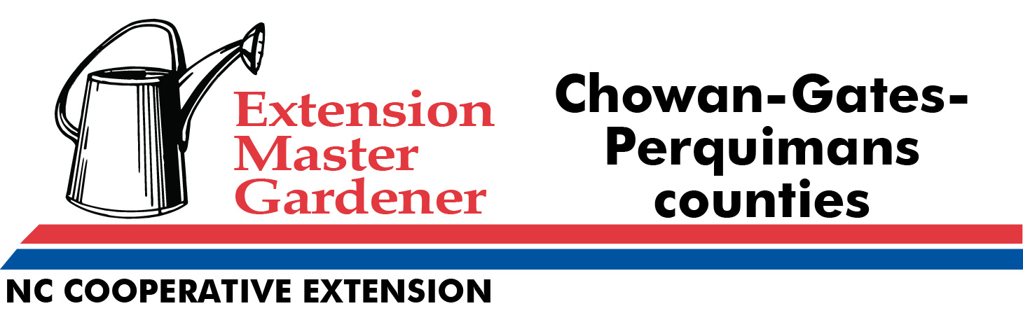

Compiled and published by the NCSU Cooperative Extension Master Gardeners of Chowan, Gates, & Perquimans Counties (Corrected as of 4/30/2013)

COMING SOON: Check out the map online at:
http://goo.gl/maps/GngrH

____________
CAMDEN COUNTY

Bray’s Farmstand | Linda Bray, 338-0240 442 East Hwy 158, Camden| Apr-Oct, Mon-Sat, 9am- 6pm |Vegetables, fruits, plants, jams & jellies.

Camden Country Store|Wilton Forbes, 142A NC Hwy 158 W Camden |12 months, 12 noon – 6 p.m. |Hoop cheese, homemade sausage, free range chicken eggs.

Huck’s Produce | Cliff Hassell, 312-6487, 783 N 343, Camden | May–Oct, Sun–Sat, 8am–7pm | Seasonal vegetables and honey.

Keeterbarn Corner Farm | Teresa Mainello, 202-3416, 225 Keeterbarn Rd, South Mills | Year Round | Free range eggs, seasonal fruits & vegetables, nuts, preserves, meat | www.keeterbarncorner.webs.com

Poor Boy’s Fruits & Vegetables |Hunter & Susan Harris , 335-1335/340-1383, 263 US Highway 158 E |Apr-Oct & Thanksgiving Wk, Sun-Sat, 8am-6pm| Vegetables, fruits, plants, jams & jellies, fresh duck and chicken eggs, pumpkins, collards.

Williams Strawberry Farm | Franklin Williams, 771-2647, 1381 Hwy 343 N, South Mills |Seasonal, 8am-7pm | Fruits, vegetables, PYO Strawberries, baked goods, jams & jellies, honey, pumpkins, collards.
Fruits & Vegetables, PYO strawberries, starting April 10th.

Williams Farm Market - Franklin Williams, N 343, South Mills, 771-2647.
8am---8pm, Seasonal. PYO strawberries. Local fruits & vegetables.

The Garden Shack | Stan & Jennifer Pynch, 482-1100, 930 Virginia Rd (Hwy 32), Edenton | Year round, Mon-Fri 9am-6pm, Sat 9am-4pm | Locally grown, seasonal produce April – September.

Triple B. Farms| Johnny Byrum, 221-4223 (call for strawberry availability and iformation) Corner of Ryland Rd & Sign Pine Rd, Tyner | Mon-Sat 8am| PYO strawberries on plastic

W. R. Bunch Produce | Joyce & Keith Bunch, 221-4594 (H) or 312-5855 (C), 2833 Rocky Hock Rd, also at Hwy 32 S at Soundside Rd., Edenton | April 26st thru Oct, Mon-Fri 8:30am – 6pm, Sat 8:30am-4pm | Fresh local & non-local produce, honey, jams, jellies, & famous Rocky Hock cantaloupes and watermelons.

Winborne & Son Farms | Emmett (333-6181) & Elliott (333-7974) Winborne, 3443 Rocky Hock Rd, | July 1-Oct 31, 7 days/wk, 8am-6pm | cantaloupe, watermelon, tomatoes, butternut squash, pumpkins (PYO or Buy), Indian corn, corn stalks, gourds, hay /wheat, straw | hay rides, farm tours | Call for details.

____________________
PASQUOTANK COUNTY (Info last updated 4/2012)

Addie’s Acres | Jeff Spear, 331-5871, 401 Jackson Dr [off Main St Ext], Elizabeth City | Sweet corn, watermelon, cantaloupe, tomatoes, squash, snap beans, lima beans, greens, collards, bell peppers, cucumbers, pears, muscadine grapes.

Bright’s Delights Produce | Shel & Margaret Bright, 338-6421, 1156 US17 S, Elizabeth City | Mon–Sat 9am-5:30pm, Year round| Local fruits, vegetables, jams & jellies.

Brothers Family Market | Mickey & Shelly, 562-2225, 1199 Chance’s Lane, Elizabeth City | Closed Sunday | Seasonal vegetables, potatoes, sweet potatoes, sweet corn, melons.

Brothers Farm Market | Bob Brothers, 619-3920, 1154 Perkins Lane, Elizabeth City | Mon-Sat 9am-6pm, Closed Sunday | Fruits & Vegetables, Homemade jellies & jams, relishes, pickled artichokes, cucumbers, asparagus, squash, arugula, cress, edible mushrooms.

Elizabeth City Downtown Market | 338-0169, call Mon-Fri Business hours for info, Mariner’s Wharf Park [waterfront], Elizabeth City | 9am–1 pm Sat, May 7th – Dec -Weather permitting| vegetables, fruits, plants, crafts, flowers.

Hall’s Creek Blueberry Farm | Donald Barclift, 333-7332, 583 Old Hall’s Creek Rd, Elizabeth City | 500 blueberry bushes |PYO |9 miles from Elizabeth City.

Scott Family Farm Produce | Scott Cartwright, 335-4508, 919 Selby Rd off Body Rd near Elizabeth City | Tues-Fri 10am-5pm, Sat 10am-3pm, Closed Sunday & Mon | Seasonal fruits & vegetables.

Warrior’s Ridge Pumpkin Patch | Sam Reid, 562-5683, Near stop sign at lower end of Body Rd, near Four Forks, across from 577 Body Rd | Labor day-Thanksgiving | Call for dates & times | Pumpkins, Fall yard decorations, Indian corn, corn shucks, wheat straw, cotton stalks & bolls. Hay bales for horses and other livestock.

_____________
CHOWAN COUNTY

A.J.Smith & Sons | 482-8977, 433 Greenhall Rd, Edenton | Sept–Oct, Mon-Sat 8am-6pm | Pumpkins, including the large ‘Prizewinner’, watermelon.

Byrum Farms | Joey Byrum, 221-4342 (call to order), 2243 Virginia Rd, Edenton. Mid Jun-Aug.
Local butterbeans (lima).

Colby Griffin | 482-7179, 1800 W. Queen St., Edenton | Mid Oct- Mid Jan, Mon-Sat, anytime | Collards.

Edenton Farmers’ Market | Vero Brentjens, 482-0826, Corner of N. Oakum & Dicks St, Edenton | May -Thanksgiving, Sat 8am-12 noon| Local produce, organic produce, baked goods, meat, local eggs, honey, nuts, flowers, cheeses, jams, jellies, peanuts and peanut butter. | (Set up to take food stamps).

James, Connie & Chad Copeland | 221-4726, 2355 Virginia Rd, Edenton | Jul - Aug, 7 days/week, 7am-9pm | Watermelon, cantaloupe and pumpkins. Oct-Jan 7 days/wk unshelled pecans.

Peace and Plenty Farm | Tessa Kelsey, 221-6559 [call to order between 10am-4pm], 848 Dillards Mill Road, Tyner | Available seasonally, year round | Free range eggs, fresh raw honey, free
range grass-fed beef (everything is all natural, no antibiotics or hormones)| peaceandplentyfarm@hotmail.com.

Pigs Plus Farms | Louis W. Nixon, 221- 8645 (Farm # with recorded Info) or 333 - 6290 (C), 311 Evans-Bass Rd, Edenton | Apr @ 25th - Aug, Mon-Sat 8am-6pm | PYO (Mon Discount) or Buy Strawberries starting | Buy regular or grape tomatoes, sweet peppers, sweet corn, sweet, banana or Jalapeno peppers, cantaloupe, honeydew, seeded/seedless watermelon, zucchini, yellow squash, long or pickling cucumbers, collards, vegetable plants | canning produce - Retail/Wholesale in A/C.

