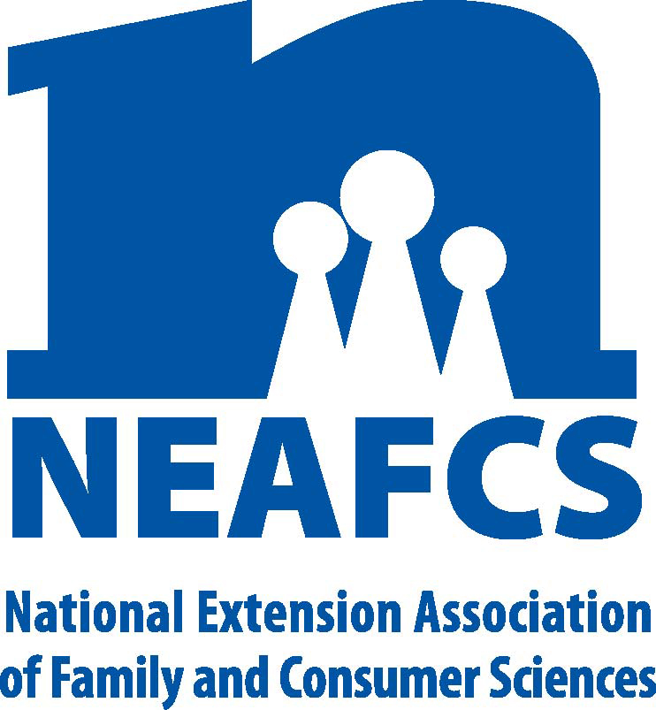

North Carolina Extension Association of
Family & Consumer Sciences

The Professional Association for North Carolina Cooperative Extension
Family & Consumer Sciences Educators
2016 By-Laws Committee Report

Objectives:
- To improve and update the by-laws, procedures and policies as needed in accordance with the changes desired by the state association using the national by-laws as a guideline. By-laws need to be suited to the changing needs of educators in North Carolina.
- To encourage all members to become familiar with and to use the By-laws in order to strengthen the North Carolina Extension Association of Family and Consumer Sciences.

Plan of Action:
- State Chair
  - Inform the district chairs of by-law changes as voted on at the 2015 state meeting.
  - Mail hard copies of the by-laws to state life members if they do not have access to a home computer with Internet capabilities.
  - The state president-elect and by-laws committee members will review the by-laws and recommend changes as needed.
  - Post the proposed by-law changes on the NCEAFCS website thirty days in advance of the Annual Meeting. Hard copies of the changes will be mailed to state life members if they do not have Internet access.
  - Partner with the Webmaster to post by-laws and proposed by-law changes on the website.

- District Chairs
  - Provide the district membership with information on update by-laws and changes at the fall meeting. Members should be encourage to visit the NCEAFCS website to view the bylaw changes in entirety.
  - Discuss by-law changes at the Winter board and notify District Chairs before their spring meetings and solicit input concerning the changes proposed.

2016 By-Laws Committee
Stephanie Parker-Helmkamp, Chair
Tracy Davis, W
Michelle Estrada, S E
Jeannie Leonard, NC
Olivia Jones, NE
Sharon English, SC

Submitted by:
Stephanie Parker-Helmkamp
President-Elect

