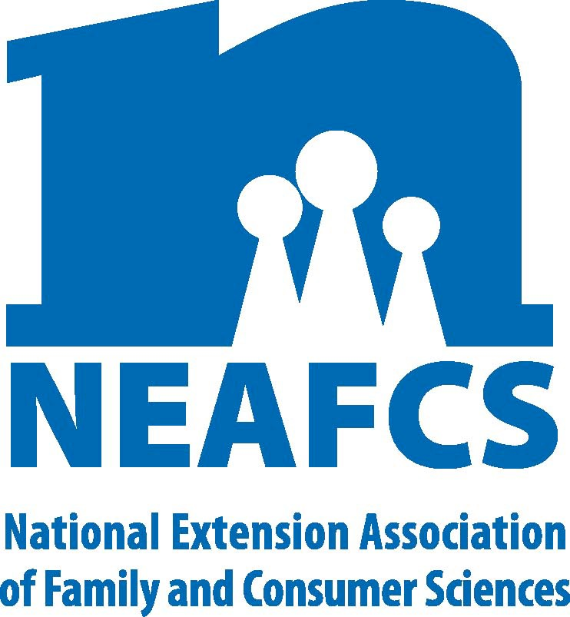
North Carolina Extension Association of Family & Consumer Sciences

The Professional Association for North Carolina Cooperative Extension Family & Consumer Sciences Educators

2016 Nominating Committee Plan of Work

Objectives:

- To submit recommendations for 2016 National Officers and Committee Chairmen to NEAFCS by February 1, 2016 and Committee Members by April 2016.

- To prepare a slate of nominees for the 2017 NCEAFCS Executive Board according to the state rotation system by May 15, 2016, at least one month prior to the state meeting.

- To prepare a slate of nominees for the 2017 NCEAFCS offices according to the state rotation system by May 15, 2016, at least one month prior to the state meeting.

Plan of Action:

Responsibility of State Committee
  - Determine eligibility of NCEAFCS National and State Nominees.
  - Inform District President Elect of the relationship between District Officers and State

Association Committee Structure
- President Elect will serve as By-Laws Chairman
- Vice President for Awards and Recognition will consult with and coordinate the following committees:

Awards Group A: DSA, NEAFCS/Greenwood Fellowship, Florence Hall, NEAFCS/Grace Frysinger Fellowship, Continued Excellence, New Professional Award, NEAFCS Extension Educator of the Year, Environmental Education Award, Marketing Package Award, Community Partnership Award, Early Career (State award only), Ada B. Dalla-Pozza Professional Development Endowment, Early Childhood/Child Care Training Award, Food Safety Award, and Extension Housing Outreach Award)

Awards Group B: Communications Awards, Para-Professional Award, Dean Don Felker Financial Management Award, Mary W. Wells Memorial Diversity
Award, Program Excellence Through Research, Youth Award (state award only), SDA Clean Homes...Healthy Families Program Award, Healthy Lifestyle, Education Grant and Excellence in 4-H After School Programming.
- Treasurer will serve as Budget committee Chairman.
- Nominating Committee Chairman will be the immediate past President or Nominating Chairman from the District of the President-Elect.
- Historian will be appointed for a three-year term by the President.

Responsibility of District Committee:

  - Submit nominations on National forms for NEAFCS officers to State Nominating Chairman by January 15, 2016.

  - Submit nominations for State officers according to the NCEAFCS Rotation (Appendix 2). The committee will submit the name, address, e-mail address, fax number and office to State Nominating Committee Chairman by May 15, 2016.

  - Secure a slate of District Officers and Committee Chairs according to the NCEAFCS Constitution and in advance of the spring meeting of the District Association when district officers should be elected by May 15, 2015. The District President-Elect must have served as a District Officer.

  - Solicit nominations for NCFCEA (“Federation” see rotation Appendix 3) and forward to State Nominating Chairman by May 15, 2016.

  - Submit a final report of district actions to State Nominating Chairman by July 1, 2016. Include District nominees for:
    - National Officers and Committees
    - State Officers and Committee Chairmen
    - District Officers and Committee Chairmen
    - Nominations for NCFCEA (Federation)

District Nominating Guidelines

  - The committee should meet in the fall and prepare the following:
District officer slate to be voted on at the Spring meeting and installed at the fall meeting including:
President; President Elect; Vice President for Public Affairs; Vice President Awards & Recognition; Vice President Professional Development; Vice President Member Resources; Secretary; Treasurer; Counselor (Immediate Past President); Budget (Treasurer); By-Laws (President-Elect); Historian (3 year term ends in 2017);
Nominating; State Meeting Chairman (District President if State Meeting will be held in your district); Life Member; Awards & Recognition Group A; Awards & Recognition Group B.

  - By January 15, 2016, the committee sends to State Nominating Committee Chairman recommendations for National Officers. The list of National Committee members must be submitted to National by March 1, 2016. All nominees must agree to attend the NEAFCS annual meeting in the year of nomination.

In even years, North Carolina may send nominations for President- Elect, Vice President for Professional Development, Member Resources and Secretary. In uneven years, nominations may be submitted for President, Vice President for Public Affairs, Awards and Recognition, Treasurer and Southern Regional Director. If elected in an even year, officers will serve in an odd year. If
elected in an odd year, they serve in an even year.

  - The District committee makes a recommendation for the state officers and appropriate state committee chairman according to the rotation system. State officer nominations for President Elect and Vice President must have served in these positions in the District Association. These names should be submitted to the State Nominating Chairman by May 15, 2016.

  - All State committee Chairman are appointed by the State President-Elect. The State Nominating Committee makes recommendations to the President Elect based on the rotation system and suggestions from the District Nominating committee.

  - Each District should make nominations for the Federation according to the rotation schedule. These names and addresses should be sent to the State Nominating Chair by May 15, 2016.

District Nominating Committee Responsibilities:

- The District nominating committee should submit the nominations for State Officers and State committees according to the NCEAFCS constitution and Bylaws. The committees will submit the name, address, e-mail address, fax number and office/committee to the State Nominating Chairman by April 1, 2016 or as soon after Spring meeting as possible.

- The rotation has been updated to note future positions for our association.

- Submit nominations on designated forms for NEAFCS officers to State Nominating Chairman by January 15, 2016. In even years, North Carolina may send nomination to NEAFCS for President Elect, Vice President for Professional Development; Member Resources; and Secretary. You must attend the National meeting the year you are nominated. Also, if elected in an even year, you will serve in an odd year and vice versa.

NCEAFCS 2017 State Officers selection by District:
See APPENDIX 2 NCEAFCS POLICIES AND PROCEDURES’ ROTATION FOR STATE OFFICES
AND POW CHAIRMEN; Revised August 27, 2012 http://www.ces.ncsu.edu/assn/nceafcs/Policies/POLICIES_Aug2012.pdf

Committee Members: Dee Furlough, Chair
TBD, SC
TBD, SE
Deborah Womack, NC
Mary Morris, NE
Margie Mansure, W

Submitted by:
Dee Furlough, Chair NCEAFCS Nominating Committee

