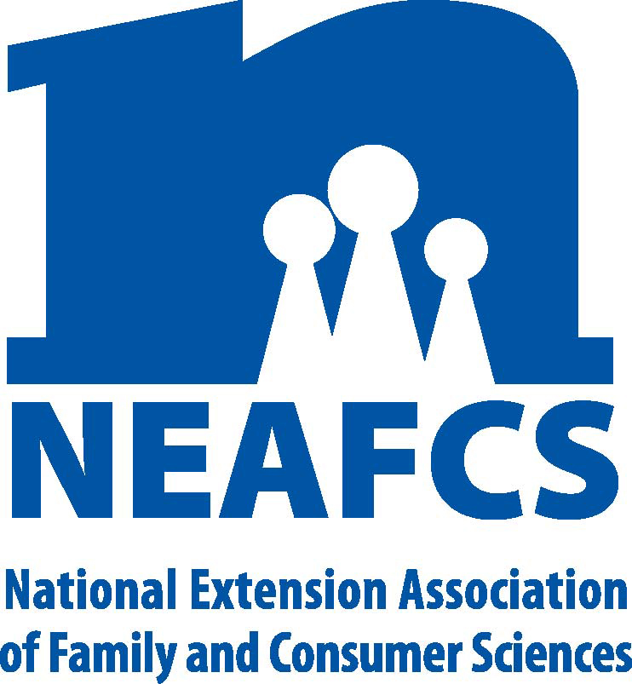

North Carolina Extension Association of
Family & Consumer Sciences

The Professional Association for North Carolina Cooperative Extension
Family & Consumer Sciences Educators
2016 NC PROCEDURE FOR SUBMITTING AWARDS:

- Refer to the Awards Manual or the Awards Web site for the most up-to-date NEAFCS Applications; for state award applications refer to the District Vice President for Awards and Recognition. State Award applications and information can also be found on the Web at the following URL: http://www.ces.ncsu.edu/assn/nceafcs/awards/awardsprogram.html

2. Read and follow on-line application process for national awards. Complete the on-line application following specific guidelines carefully. Pay special attention to word limits, spacing, and appropriate signatures.

3. Make 5 copies of your completed application plus one on-line application copy. Five copies are required for all categories. Please note: National may ask for a fewer amount of copies for judging purposes.

4. By Monday January 4, 2016, mail 5 copies plus one copy uploaded on-line (For National Awards) of your application by traceable mail to the DISTRICT Awards and Recognition Vice-President. On January 11, 2016, District VPs will bring Awards applications to the NCEAFCS Mid-Year Board Meeting or mail awards applications (by traceable mail) to the State Vice President of Awards. The State Vice President for Awards will mail appropriate awards to District VPs and Awards A and B chairs by Tuesday, January 19, 2016.

5. By Tuesday, January 26, 2016, District Vice President for Awards, will judge award applications. Complete an individual score sheet for each application with comments, and mail original score sheets to the appropriate Awards A (Mary Morris) or B (Janice Smith) Chair. Scan and e-mail State Vice President for Awards a copy of individual score sheet for each application.

6. Group A and B Chairs will receive the judging results from Group A and B Judges, date and tally the results numerically. In case of tie, the Group (A or B) Chair will review the application and vote. Complete the Group Tally Sheet listing ALL award applicants with first and second place winners highlighted. Complete the Award Winner Sheet indicating all first place winners. By Monday, February 1, 2016, mail all score sheets, Group Tally and Winners Sheets to State Vice President. Send by certified traceable mail.

7. By February 15, 2016, State Vice President will submit eligible applications to the regional director of The NEAFCS by traceable mail.

NOTE: Applications received after the deadline, incomplete applications and applications that do not include at least 5 copies will not be judged.

FOR ADDITIONAL INFORMATION REFERE TO THE 2016 AWARD PLAN OF WORK

2015 NCEAFCS Awards and Recognition Committee:
Lori Ivey – State Vice President for Awards ad Recognition, Chair
District Vice Presidents for Awards and Recognition are:
North Central - Geissler Baker
Northeast - Mary Morris
South Central - Kristen Davis
Southeast - Trudy Pickett
West - Margie Mansure

